In-class Assignment 2.

- convolution operations
Task: Students will slide the kernel across the input (stride = 1) and compute the remaining values in the 4×4 output matrix.
Submission Guidelines:
- Calculate the Output Size use the formula talked in the class.
- Fill in the 4×4 output matrix using the convolution process.
- Show step-by-step calculations for at least three more positions in the output.
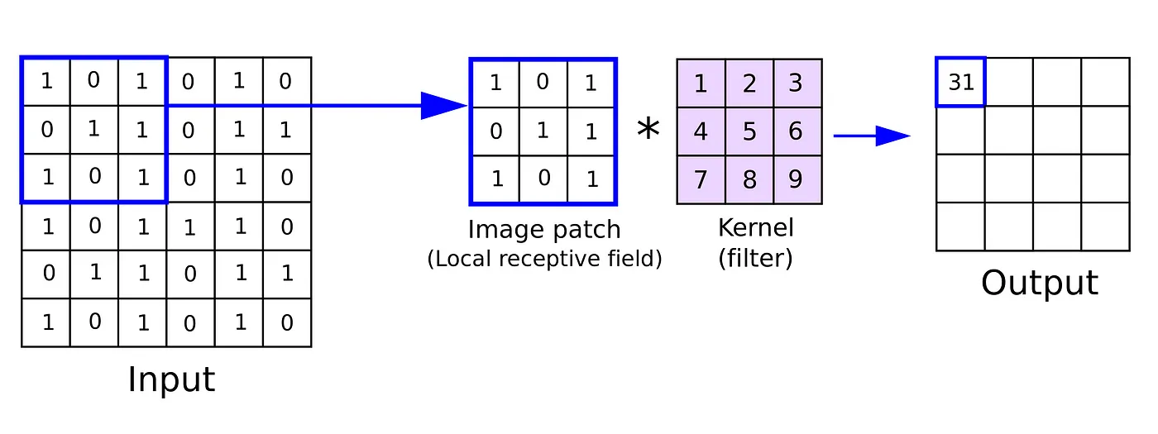

Solution:
Step1
Position (0,0):
- Region:

1 0 1
0 1 0
1 0 1
- Convolution Result: 25

Position (1,1):
Region:

1 0 1
0 1 0
1 0 1
Convolution Result: 25
Position (2,2):
Region:
1 0 1
0 1 0
1 0 1
Convolution Result: 25

- CNN layers
Apply the convolution layer, activation layer, and pooling layer operation to extract the inside feature. Use the image which chose by yourself.
Step:
- import the necessary libraries
- set the parameter
- define the kernel
- Load the image and plot it.
- Reformat the image
- Apply convolution layer operation and plot the output image.
- Apply activation layer operation and plot the output image.
- Apply pooling layer operation and plot the output image.

Code screenshots:
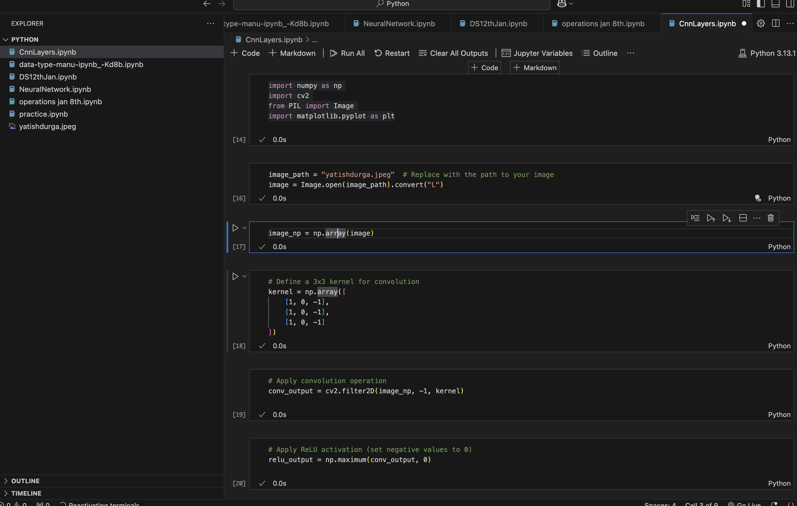
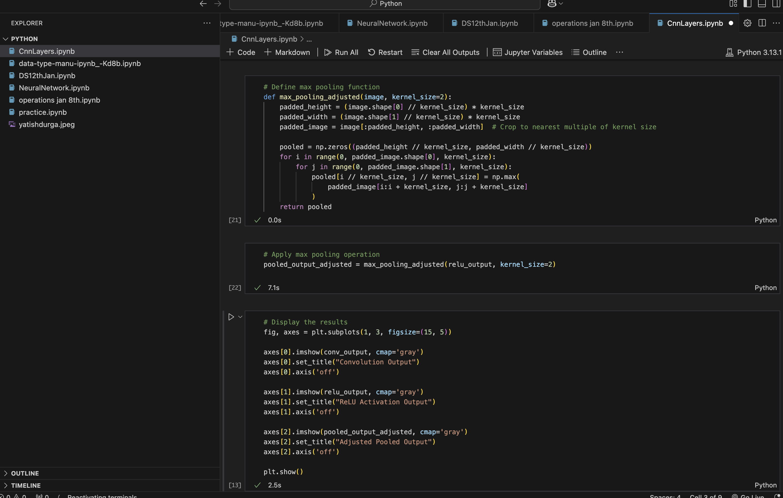
Results from CNN:
